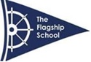The Flagship School Academic Curriculum by Key Stage and subject

The Key Stage 2 and Key Stage 3 Curriculum | Hours per week | Mandatory/ Voluntary | Comments
Maths – National Curriculum  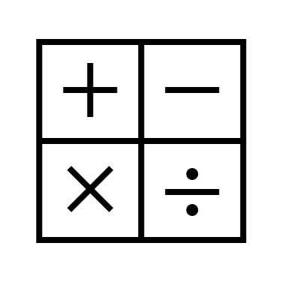 | 4 hours | Mandatory | At KS2 and KS3, we use Ark Maths Mastery Curriculum. This is an evidence-based approach to pupils developing mastery of maths– focusing on developing mathematic language, a deep understanding of mathematical concepts and progression routes built-in.  Maths will be taught in discrete lessons, with skills being promoted, used and applied in other curriculum areas to develop confidence and competence in number work and reasoning. Learning and applying mathematical concepts outside of the classroom setting will be encouraged to focus on deepening knowledge and mathematical skills.
English – National Curriculum | 4 hours | Mandatory | English will be taught in discrete lessons and through a cross-curricular approach using Curriculum Maestro, which develops and embeds skills through other subject areas. Daily supported reader, and Pearson’s Bug Club readers, along with Oxford Readers, will be used in Key Stage 2  At Key Stage 3, we have implemented Dyslexia Gold Pearson’s Rapid Readers for pupils who require additional literacy support.  Class novels, poetry and non-fiction multimodal texts will be taught every term, and these are linked to the cross-curricular projects, e.g. The Boy in Striped Pyjamas with 2nd WW
Science – National Curriculum  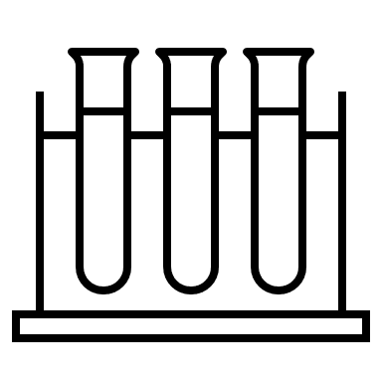 | 3 hours | Mandatory | Science will be taught in discrete lessons and through a cross-curricular approach.  At KS2, we will be using Pearson’s Science Bug curriculum. Clear progressions and a range of assessments will be adapted and personalised for our pupils alongside our cross-curricular topics, fully aligned to NC outcomes.  Cornerstones Cross-Curricular projects will be included within timetabled Science lessons once a week, e.g. ‘Blood Heart’ Animals including Humans’ and ‘Food for Life.’  At KS3 and GCSE, there is a five-year curriculum plan leading to EDEXCEL’s combined Science GCSE. All resources are digital and used through ACTIV Learn online portal.  STEAM Cross-Curricular projects will be included throughout the term. These will take place during one of the timetabled Science lessons each week: E.g. Plastic waste solutions, Arctic STEAM projects, Minecraft Education. We will ensure that these topic areas are aligned with the discrete topics taught in the schemes of work.
Computing – National Curriculum | 1 hour | Mandatory
Humanities (history and geography) – national curriculum  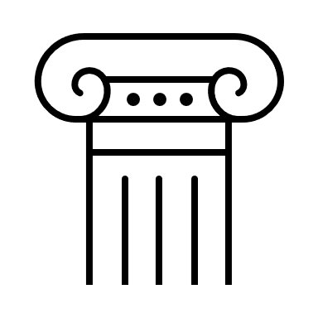 | 1 hour | Mandatory | KS2 will follow a 4-year programme and KS3 a three-year programme. There will be enrichment days to supplement the curriculum time and expand learning beyond the classroom and into the environment and the wider world.  At KS2, we have a History and Geography curriculum mapped out term by term. There are also a variety of cross-curricular units of work that incorporate all outcomes within the National Curriculum. Clearly defined progression maps ensure broad and balanced curriculum coverage with exciting, memorable experiences mapped into the timetable.  Cornerstones Cross-Curricular projects will take up one of the timetabled Humanities lessons once a week, e.g. Dynamic Dynasties, Britain at War.  KS3 History will be taught as a three-year EDEXCEL course that can, if desired, lead to a two year GCSE course to take the EDEXCEL GCSE History  One of the weekly timetabled History lessons will incorporate our cross-curricular themed lessons. E.G Evacuees, Plastics etc.
Creative and Performing Arts – national curriculum  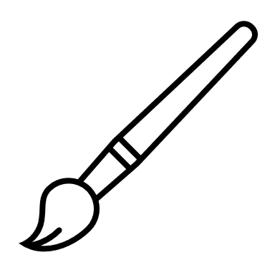 | 1 hour | Mandatory | Delivered as part of the cross-curriculum project. Creativity and expression will be nurtured and developed through a high-quality arts education. Pupils will have regular singing and whole-class activities. Creative drama opportunities will be linked to English. Enrichment opportunities, museums, art galleries, theatres, and places of culture and technological interest will support the wider curriculum.  At KS2, our Cross Curricular topics will incorporate creative and performing arts, but there will also be discrete lessons to build on skills and work on our SEMH. Drama will be used as a powerful tool to open up the curriculum in many ways, build literacy and social skills and broaden our pupil’s horizons.  Cross-Curricular Projects include Tints, Tones and Shades’, The Human Body’ ‘Evacuees.’  At KS3, Art and Design will again be a large part of our Cross Curricular curriculum.
PE | 2 hours | Mandatory | All pupils will have physical education lessons each week, incorporating a mixture of sports and physical development activities.
DT | 1 hour |  | Delivered as part of the cross-curriculum project
PHSE (this will include citizenship, sex and relationships education)  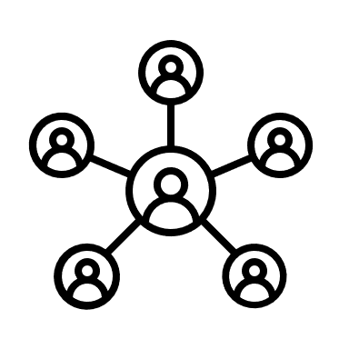 | 2 hours | Mandatory | Pupils will follow the PSHE+C programme appropriate to age, covering key aspects of well-being such as self-esteem, staying safe and healthy, growing up, friendships, SRE, and an understanding and appreciation of diversity and differences. It will include teaching the importance of British values and inclusion. PSHE+C will be delivered as a one-hour discrete lesson, alongside being embedded within cross-curriculum projects. The Health Education and Relationships Education (primary) and the secondary Relationships and Sex Education (RSE) aspects of PSHE education are compulsory in all schools from 2020.  PSHSE  Our curriculum is designed specifically for our SEND pupils needs and is a cross phased approach. We are working with the PSHSE association to ensure we are fully compliant with the new statutory Health Education and RSE/Relationships Education guidance.  We are building our cross-curricular approach drawing on a range of existing core curricula (Cornerstones) that will be fully mapped out term by term, integrated NC discrete subjects and SEMH therapeutic goals.  We are adapting this to ensure:  It fully reflects NC expectations of each core curriculum area (history, geography, art and design)  It enables clear progression and progression mapping for individual pupils – across separate curriculum areas and cross-curriculum areas (key for our pupils to allow them to test out learning and concepts in a different context)  It includes opportunities to develop core executive functioning skills (planning, managing setbacks) alongside core communication skills (working collaboratively with others, taking turns, managing responsibility etc.) that our pupils need.
RE | 1 hour | Mandatory | All pupils will have discrete RE lessons with links made to other curriculum areas where appropriate. Lessons will cover key content in the national curriculum and the Standing Advisory Council on Religious Education (SACRE) guidance.  KS2 RE  RE will be taught within cross-curricular lessons and as discrete topics  KS2:  • Parinirvana,  • Lent,  • Jewish festivals  Pupils will describe and connect different features of the religions and world views they study, discovering more about celebrations, worship, pilgrimages, and the rituals, which mark important points in life to reflect on their significance.  They will describe and understand links between stories and other aspects of the communities they are investigating, responding to a range of sources of wisdom and to beliefs and teachings that arise from them in different communities.  Pupils will discuss and present their own and others’ views on challenging questions about belonging, meaning, purpose and truth, applying their ideas in different forms, including reasoning, music, art and poetry.  KS3 RE  Examples of units  KS3.1: Belief and practice: Buddism  KS3.2: Belief and practice: Humanism  KS3.3: Belief and practice: The Baha'i Faith  KS3.4a: Religion in writing  This will lead to the gaining of and the deployment of skills such as  • Consider and apply ideas about ways in which diverse communities can live together for the wellbeing of all, responding thoughtfully to ideas about society, values and respect.  covered  • Discuss and apply their own and others’ ideas about ethical questions, including statements about right and wrong and what is just and fair, and express their ideas clearly in response.
Enrichment – social and emotional skills development and life skills development (described more fully within the enrichment and life skills section below)  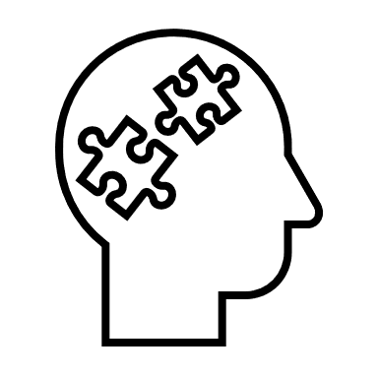 | 2.5 hours |  | Enrichment and social skills activities will be delivered for all pupils at the start of the day, during discrete lessons to focus on particular skills development (speech, language and communication skills and executive functioning skills) - linked where appropriate to formal qualifications such as the English Speaking Board, and as part of a broader programme enrichment activities to enable pupils to develop core social, communication and relationship skills, engage with careers and develop core life skills.  We use the Empowerment Approach as part of our core SEMH curriculum.

